**Rotation of Axes**

*X*

***x***

**

*P*(*x*, *y*)

*P*(*X*, *Y*)





***Y***



***X***

***x***

*r*

*Y*

**O**

Let, $P\left(x,y\right)$ be a point under $xy-$ coordinate system. $OP=r$ makes an angle $ϕ$ with positive $x-$ axis.

$x=r cosϕ$,

$y=r sinϕ$.

Suppose that the coordinate system is rotated through an angle q keeping the origin fixed. If P has coordinates  referred to the new axes, then

$$X=rcos\left(ϕ-θ\right)$$

$$⟹X=r cosϕ\cos{θ+r sinϕ\sin{θ}}$$

$$⟹X=x\cos{θ+y\sin{θ………..\left(1\right)}}$$

And

$$Y=r\sin\left(ϕ-θ\right) \\ ⟹Y=r\sin{ϕ\cos{θ-r cos{ϕ\sin{θ}}}} \\ ⟹Y=y\cos{θ}-x\sin{θ.} \\ ⟹Y=-x\sin{θ+y\cos{θ……………\left(2\right)}}$$

Converting equation (1) and equation (2) into matrix form we get,

$$\left(\begin{matrix}X \\ Y\end{matrix}\right)=\left(\begin{matrix}\cos{θ} & \sin{θ} \\ -\sin{θ} & \cos{θ}\end{matrix}\right) \left(\begin{matrix}x \\ y\end{matrix}\right)$$

$⟹\left(\begin{matrix}x \\ y\end{matrix}\right)=\left(\begin{matrix}\cos{θ} & -\sin{θ} \\ \sin{θ} & \cos{θ}\end{matrix}\right) \left(\begin{matrix}X \\ Y\end{matrix}\right)$

$$⟹x=X\cos{θ-Y\sin{θ}}$$

$y=X\sin{θ+Y\cos{θ.}}$

**General Equation of Second Degree**

The general equation of second degree is

 --------------- (1)

Where *a, h, b, g, f* and *c* are constants.

**Angle of rotation to remove *xy* term from general equation of second degree**

The general equation of second degree is

 --------------- (1)

Under rotation through an angle , the transformation equations are





and the general equation of second degree becomes





which can be written as



where













The transformed equation will be independent of the product term  if  i.e.





$\tan{2θ=\frac{2h}{a-b}}$.

The nature of the **conics** represent by (1)



may be predicted by the sign of the discriminant

.

Results are summarized below:

|  |  |
| --- | --- |
| **Conditions on** | **Regular Conics** |
|  | Ellipse |
|  | Hyperbola |
|  | Parabola |

**To reduce to standard form, we may follow the following steps:**

Rotate the coordinate axes through an angle q such that to get rid of *xy* term and then use translation to reduce to standard form.

**Example:** Find the angle of rotation to remove *xy* term fromand hence write the transformed equation. Also reduce them to standard form and sketch them showing both set of axes.

**Solution:** Identifying with  and and choosing q such that



From the triangle we see that



The values of  and  can then be computed from the half-angle formulas:













The transformation equations become



and

Substitution in the original equation gives



Collecting similar terms



or .

or.

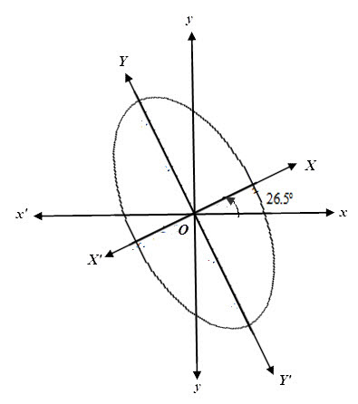

**Example:** Find the angle of rotation to remove *xy* term fromand hence write the transformed equation.Also reduce them to standard form and sketch them showing both set of axes.

**Solution:** Identifying with  and and choosing q such that



From the triangle we see that



The values of  and  can then be computed from the half-angle formulas:









7



The transformation equations become



and

Substitution in the original equation give



Collecting similar terms



or 

or  .

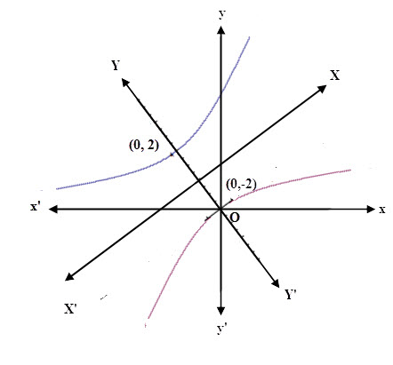

**Example:** Find the angle of rotation to remove *xy* term fromand hence write the transformed equation. Also reduce them to standard form and sketch them showing both set of axes.

**Solution:** Identifying with  and and choosing q such that









1

From the triangle we see that



The transform equations are



and

Substitution in the original equation gives



Collecting similar terms



or 

or  .

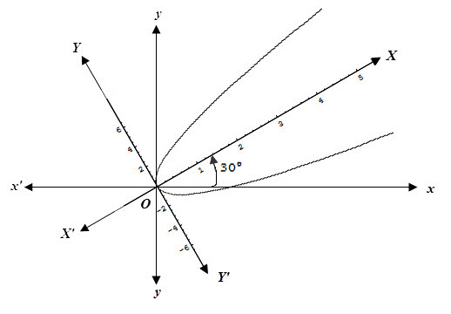

**Exercise**

1. Find the angle of rotation to remove *xy-*term from the following curves.

(a)  (b)  (c)

2. The Coordinate axes are rotated by the following given angle . Find the transformed equations of the following curves. Also reduce them to standard form and sketch them showing both set of axes.

(a) ${7x}^{2}+6\sqrt{3}xy+13y^{2}=64, θ=\frac{π}{3}$

(b) ${5x}^{2}-8xy+{5y}^{2}=9, θ=\frac{π}{4}$

(c) $4x^{2}-10xy+4y^{2}+9=0, θ=\frac{π}{4}$

(d) $x^{2}+10\sqrt{3}xy+11y^{2}+40, θ=\frac{π}{3}$

(e) $x^{2}-2xy+y^{2}+4\sqrt{2}x+4\sqrt{2}y-16=0, θ=\frac{π}{4}$

(f) $x^{2}-2\sqrt{3}xy+3y^{2}-16\sqrt{3}x-16y=0, θ=\frac{π}{6}.$